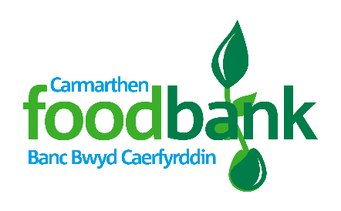
Towy Church Admin. Centre
Llansteffan Road, Johnstown
Carmarthen. SA31 3BP

01267 225 996
carmarthenfoodbank@towychurch.co.uk
www.carmarthen.foodbank.org.uk

Tel:
Email:
Website:

Volunteer Application Form

Thank you for your offer to help with Carmarthen foodbank. In order for us to process your application please would you answer the following questions:
(If you have any questions about your application or would like help completing it please contact Judy on 01267 225996 or email carmarthenfoodbank@towychurch.co.uk)
References (not family members please)
Referee 1
Name:

Daytime tel. number or email address:

Relationship to you:

Referee 2
Name:

Daytime tel. number or email address:

Relationship to you:
Title: _____________________________
Full Name: (BLOCK CAPITALS)
___________________________________

Address: ___________________________
___________________________________
___________________________________
Postcode: __________________________

Tel No: _____________________________
Email: ______________________________
Date of Birth: ________________________

Next of Kin:
Name: _________________________________
Tel No: ________________________________
Relationship: ___________________________
Contact in case of emergency (if different)
Name: ________________________________
Tel No: _______________________________
Relationship: __________________________

I would be interested in helping regularly in the following area(s):
- Foodbank Centre Warehouse
- Maintenance/DIY Assisting in the office
Marketing/Public relations Fundraising
Supermarket collections Delivery or Collections (using own vehicle)
Specialist skills: _________________________________

I am available for: (please tick and circle as appropriate)
One off events i.e. Supermarket collections, Harvest food sorting, annual stocktake
1-4 hours a week AM / PM on: Mon / Tues / Wed / Thurs / Fri / Sat
Full Day(s) on: Mon / Tues / Wed / Thurs / Fri / Sat
Other: _________________________________________
Do you have any health problems that we should be aware of? Yes No
If yes, please give details:

Please tell us your previous work experience or qualifications:

Would you be willing to for us to submit for a DBS criminal record check, if required? Yes No

Do you have any criminal convictions (except those ‘spent’ under the Rehabilitation of Offenders Act 1974)? (NB: this does not necessarily prevent you from volunteering) Yes No
If yes, please give details:

Please state your reasons for volunteering:

Please give us any information you think may be useful to us:

How did you hear about volunteering at Carmarthen foodbank?
Data protection: Carmarthen foodbank will hold your details on file but will not release them to a third party.
I confirm that the above information is complete and correct. I consent to the processing of this data in the consideration of my application and during the course of my volunteering, if applicable.
Signature: _______________________________ Date: ______________________
Signature of parent/guardian if applicant is under 18: _____________________ Date: ___________
Thank you!
Please return completed form to: Towy Church Admin. Centre, Llansteffan Road, Johnstown. Carmarthen. SA31 3BP

